Hardware Design Document
of
ML Based Agriculture Robot

Title | ML Based Agriculture Robot
Document | Hardware Design Documents
Document Ref | RKA_MARS_2V00_HDD_0V01
Date | 22/08/2026
Prepared By | Kamalesh R
Guided By | Banumathi S
Submitted to | MSME

Table of Contents
1 REQUIREMENT 3
1.1 Hardware Requirement: 3
1.2 Software Requirement: 3
1.3 Mechanical Requirement: 4
1.4 Power Supply Requirement: 4
1.5 External Interface Requirement: 5
1.6 Internal Interface Requirement: 5
2 SYSTEM SPECIFICATION 6

SCOPE
This document describes the hardware design and implementation of the system, including the electrical architecture, component selection, power supply design, interfaces, signal connectivity, and PCB design considerations.

REFERENCE
Sl.No | Document | Reference
1 | System Requirement Document of ML Based Agriculture Robot | RKA_MARS_2V00_SyRD_0V01
2 | Block Diagram of ML Based Agriculture Robot | RKA_MARS_2V00_BD_0V01

SYSTEM SPECIFICATION
Sl.No | Parameter | Specification
1 | Category | Commercial - Proto
2 | Stage | Proto
3 | Power Supply Source | Internal Battery
4 | Operating Voltage | 12VDC and 7.2VDC
5 | Current Consumption | 2A (max) @12VDC and 5A (Max) @ 7.2V
6 | Dimension | 600 x 450 x 700 mm
7 | Weight | Less than 6Kg
8 | External Communication | Bluetooth
9 | Inter-Module Communication | UART (Modified)
10 | Control | Automatic / Semi-Automatic
11 | Navigation | GPS / CV
12 | ML/DL Model | YOLOv4 or advanced
13 | Controlling Element | RP2040 (PICO)
14 | Processing Element | Raspberry Pi-5

INTRODUCTION
The population of India is highly increasing day by day. But due to lack of manpower and knowledge in the agriculture field the yield and profit are less. Implementation of Robotics and Artificial Intelligence in agriculture will increases the Yield and profit for the farmers. Agriculture work like Fertilizing, Monitoring, and Diseases detection can be done by the single robot using various techniques. Modern Micro-controller and Micro-processor like Arduino and Raspberry Pi can be used for interfacing multiple sensors, actuator, and implementation of Machine Learning. Sensors and Special electrical machines like Stepper motor and Servo motor can be used for accurate result of Weeding and Fertilizing. Machine Learning can be used for Crop monitoring and identification of disease. Implementation of IoT enables the user can be easily monitor crop through Internet in anywhere. It is user (farmer) friendly, and less manpower required.

SYSTEM OVERVIEW

BLOCK DIAGRAM
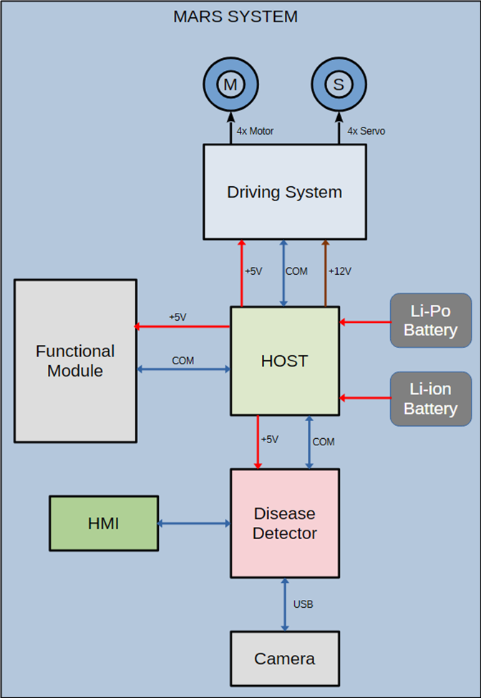

BLOCK LEVEL DESCRIPTION

HOST Module
Host Module is the master module which controls the

Driving System

Disease Detector

Functional Module

Human Machine Interface

Camera

Li-ion Battery

Li-Po Battery

Driving Motor

Steering Servo Motor

